# Project Planning Phase

## Project Planning (Product Backlog, Sprint Planning, Stories, Story points)

|  |  |
| --- | --- |
| Date | 07 NOV 2022 |
| Team ID | PNT2022TMID38215 |
| Project Name | Project – Nutrition Assistant Application |
| Maximum Marks | 8 Marks |

**Product Backlog, Sprint Schedule, and Estimation (4 Marks)**

Use the below template to create product backlog and sprint schedule

|  |  |  |  |  |  |  |
| --- | --- | --- | --- | --- | --- | --- |
| **Sprint** | **Functional Requirement (Epic)** | **User Story Number** | **User Story / Task** | **Story Points** | **Priority** | **Team Members** |
| Sprint-1 | Registration | USN-1 | New user enters into the System He/ She can register into the Application by entering mail Id and Password. | 8 | High | Team Lead |
| Sprint-1 |  | USN-2 | The user will receive conformation Email | 5 | High | Team Member -1 |
| Sprint-1 | Login | USN-3 | After Successful registration the user can Log into the application by entering the registered Mail Id and Password | 8 | Low | Team Member- 2 |
| Sprint-2 | Dashboard | USN-4 | User can get into the Dashboard only when the Verification Successful. After the user can access the displayed information in the Dashboard. | 8 | Medium | Team Member-3 |
| Sprint-2 | Calorie prediction | USN-5 | As a user, I can upload photos to predict the calorie values. | 10 | High | Team Lead, Team Member-1 |
| Sprint-3 | Diet chart | USN-6 | As a user, I can view the diet chart generated by the tool. | 7 | High | Team Member- 3 |

|  |  |  |  |  |  |  |
| --- | --- | --- | --- | --- | --- | --- |
| **Sprint** | **Functional Requirement (Epic)** | **User Story Number** | **User Story / Task** | **Story Points** | **Priority** | **Team Members** |
| Sprint-4 | Quality Assurance | USN-8 | As a user they have some credibility issues while using application. | 8 | High | Team Member- 2 |
| Sprint-3 | Train Model | USN-9 | As an administrator, I must use the most  suitable ML model for prediction of calories. | 9 | High | Team lead, Team Memebr-1 |
| Sprint-3 | Health Details | USN-10 | As a user I have to enter my health details to get the proper diet chart. | 7 | High | Team Member-3 |
| Sprint-3 | Food Recommendations | USN-11 | As a user I can get the food recommendations as per my health  conditions. | 9 | High | Team Member- 2 |

**Project Tracker, Velocity & Burndown Chart: (4 Marks)**

|  |  |  |  |  |  |  |
| --- | --- | --- | --- | --- | --- | --- |
| **Sprint** | **Total Story Points** | **Duration** | **Sprint Start Date** | **Sprint End Date (Planned)** | **Story Points Completed (as on Planned End Date)** | **Sprint Release Date (Actual)** |
| Sprint-1 | 20 | 6 Days | 24 Oct 2022 | 29 Oct 2022 | 20 | 29 Oct 2022 |
| Sprint-2 | 20 | 6 Days | 31 Oct 2022 | 05 Nov 2022 | 20 | 05 Nov 2022 |
| Sprint-3 | 20 | 6 Days | 07 Nov 2022 | 12 Nov 2022 | 20 | 12 Nov 2022 |
| Sprint-4 | 20 | 6 Days | 14 Nov 2022 | 19 Nov 2022 | 20 | 19 Nov 2022 |

# Velocity:

Imagine we have a 6-day sprint duration, and the velocity of the team is 20 (points per sprint). Let’s calculate the team’s average velocity (AV) per iteration unit (story points per day)

**AV = Sprint duration**

**Velocity**

|  |  |
| --- | --- |
| **Sprint** | **Average Velocity** |
| Sprint-1 | 6.6 |
| Sprint-2 | 8 |
| Sprint-3 | 7.5 |
| Sprint-4 | 8 |

Total Average Velocity=7.5

# ROADMAP:

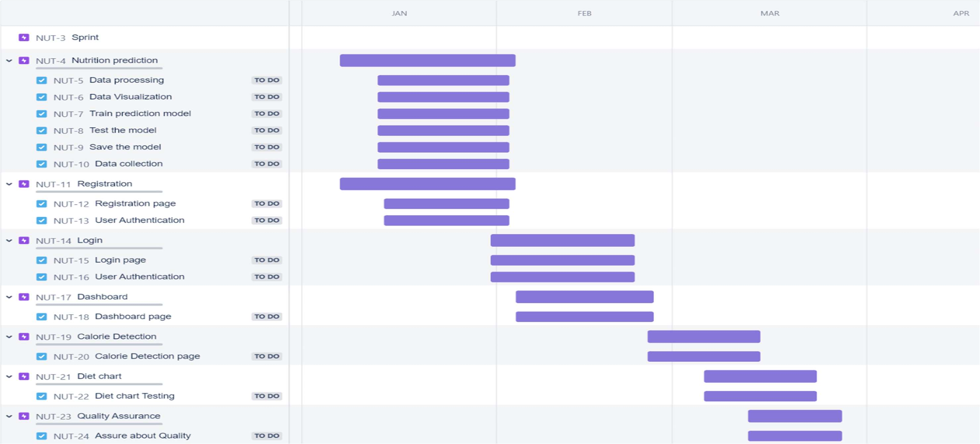

**BURNDOWN CHART:**

